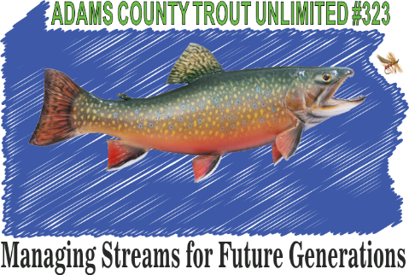

ADAMS ANGLER
Summer 2017

ACTU ASSISTS THE Pa.F&BC WITH INSEASON STOCKING
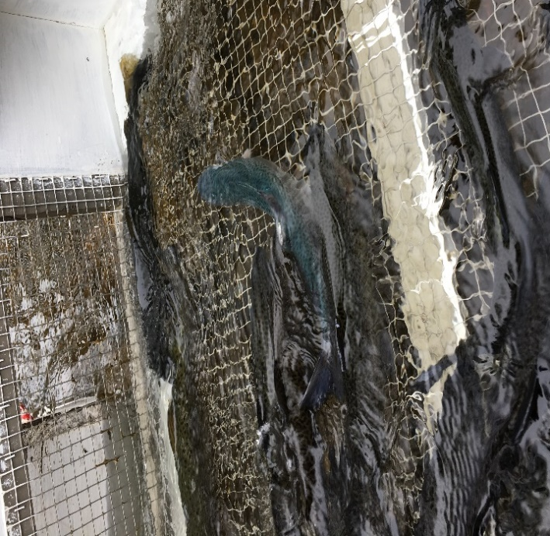
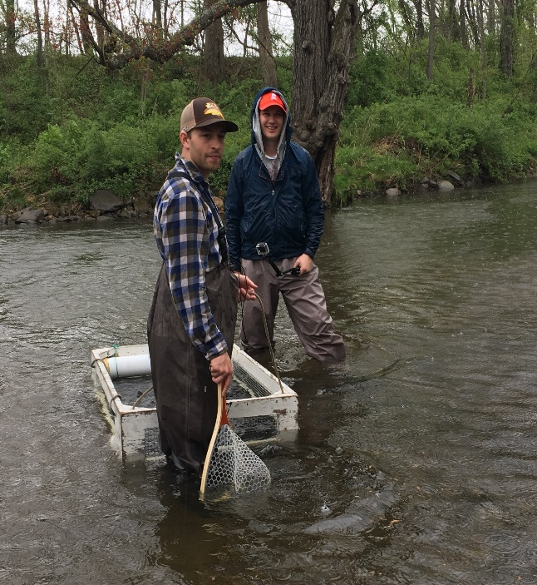
Blue Trout 1 of 1 million hatched Tyler & Brandon making it look easy
The Adams County Chapter is proud to begin a partnership with the Gettysburg College fly fishing club. The anglers are excited about our activities and protecting our streams. We look forward to working with their group. Tyler showed above (in back) is their committee chair and enjoys the outdoors.

ACTU Store -----------Be sure to check out all the great items now available with the chapter's logo. Visit: http://shop.jamcoembroidery.com/Adams_County_Trout_Unlimited. Items can be shipped directly to you, or you can save shipping costs by picking up the items at a chapter meeting.
Do you shop on Amazon? If so, you can now make a donation to ACTU every time you shop through Amazon Smile. There is no additional cost to you and Amazon will donate 0.5% of your purchase to ACTU. Visit https://smile.amazon.com/ch/23-2222233 for more information.

FISHING DERBY AT HOFFMANN HOMES Senator Rich Alloway has planned another opportunity for children to learn and enjoy fishing. On June 10th starting from 8 till 11 at Hoffmann Home. The pond is located directly across from the home. All equipment will be supplied. We are in need of volunteers to assist in the program call 253-6680.
Better Roads and Cleaner Streams- Deb Musselman
In Adams County, we have transportation networks that allow for the movement of people through the landscape, including traversing streams. But these intersections of roads and streams can cause impacts to both the road and the stream. The Dirt and Gravel Road Maintenance Program was started in the late 1990s with its focus being on unpaved roads and their impact on streams. At the end of 2013, the Program was expanded to include a funding source for low volume paved roads. The number of potential worksites increased due to the number of Adams County’s rural paved roads. Not only was there new funding for the low volume paved roads in Adams County, there was a five-fold increase in the funding for improvements made to dirt and gravel roads, allowing for the consideration of projects that were too costly to do under the Program’s original funding allocation. The Program’s purpose remains the same, to help municipalities address pollution from low volume roads. Improved drainage and improved road surfaces not only give motorists a better road but also improve the water quality of streams which is the goal of the Program.
The Adams County Conservation District (ACCD) administers the Program at the county level and is the local in-the-field technical support for the municipalities. The Program was set up to have some local control so there is a local Adams County Quality Assurance Board (QAB) which makes recommendations on local policies to the Adams County Conservation District Board. The ACCD reaches out to the local municipalities informing them of the potential for funding worksites and lets them know about training sessions that are a requirement to be eligible to receive funding. There are 15 municipalities in Adams County that have attended the required Environmentally Sensitive Road Maintenance Training session which makes them eligible to apply for funding through the Program. There are training sessions planned throughout the state this year.
Some of the work that has been done on worksites in the past has been ditch work, underdrains, cross pipes, and road surface grading. With the new funding, while some of the same types of work have been done, larger stream crossing culvert replacements have been done as well.
Adams County has completed/committed $457,934.68 on dirt and gravel surfaced roads since the start of the program in the late 1990s with 15 completed sites and 3 contracted sites. A total of $240,121.53 has been completed/committed since 2013 on low-volume paved roads in Adams County with 6 completed sites and one contracted site.
The Dirt, Gravel and Low Volume Road Maintenance Program emphasizes drainage improvements allowing water to get through the road minimizing erosion and reducing sediment pollution into the stream. Not only will you be traveling on a better road, the stream will be cleaner as a result of the work that was done through the Dirt, Gravel and Low Volume Road Maintenance Program. 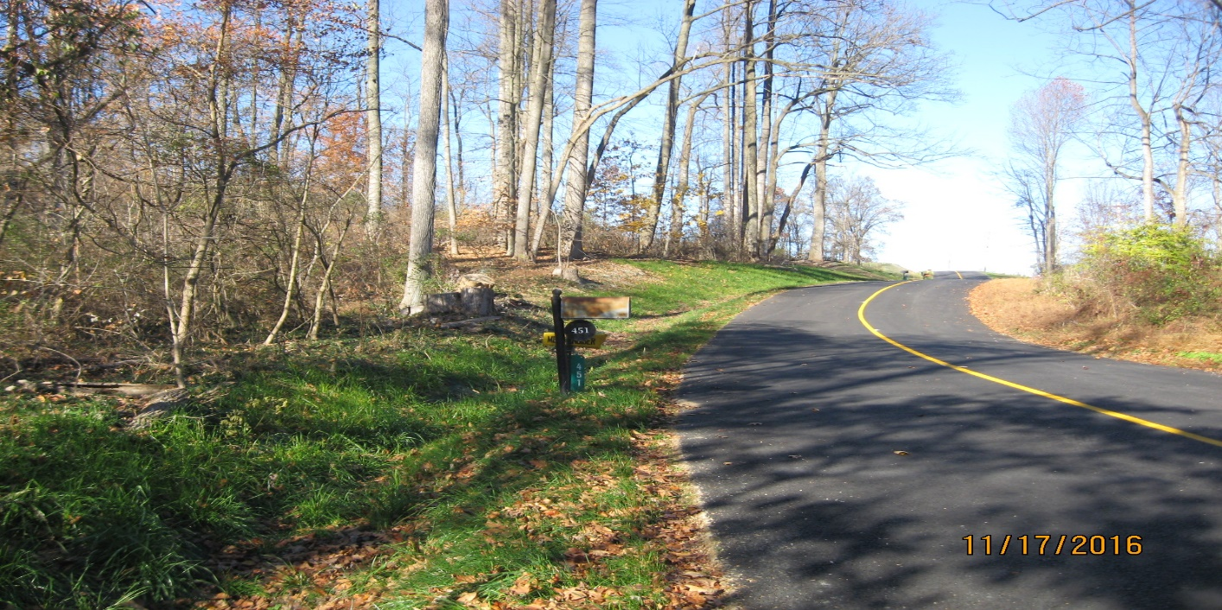

IMPORTANT NOTICES:
The next chapter meeting will be held on June 20th streamside at the Gladys Rodgers Pavilion starting at 6PM please add your favorite covered dish for all to enjoy.
The board is working to secure a date for the 40th anniversary celebration and family fun night with Jack Hubley keep viewing our newsletter for updates coming soon.

TIC Trout Releases - Adam McClain

Trout in the Classroom is a hands on program in which students in 4th grade through college level learn about coldwater conservation while raising brook trout from eggs to fingerlings in a classroom aquarium. In 2009, the Conservation District and ACTU initiated the first Trout in the Classroom (TIC) program in Adams County. Now, 11 educational institutions are managing the TIC program: Bermudian High School (HS), Biglerville HS, Fairfield Elementary and Middle School, two at Gettysburg HS, Gettysburg Montessori Charter School, New Oxford HS, St. Francis, Harrisburg Community College – Gettysburg Campus, and Strawberry Hill Nature Preserve.

Each program started with about 300 fertilized Brook Trout eggs in November, but the survival of the trout had varied among the programs from 0 to 200+. This year, some of our teachers have run into issues with their programs including poor water quality (nitrite and ammonia) and disease (ich).

Between April 22nd and May 11th our 11 programs released their trout at our 4 annual “Trout Release Events” and a few smaller events. All the Trout Release Events were held at Strawberry Hill Nature Preserve and presentations included watersheds, wetlands, macroinvertebrate studies, land use planning exercises, fly and spin casting, and fishing ethics. We estimated that approximately 370 students in Adams County were involved in releasing trout this year.

Special thanks to Adam McClain, Wayne Belt, Hank Rajotte, Richard Lewis, April Swope, pad on the back to Joe Whitmore, PFBC Rachael Thrumer-Diaz, PFBC Darin Gephart, Jim Fisher, and the fellow who owns the pottery shop up the street from Strawberry Hill Nature Preserve who worked thru driving rains on the last day.

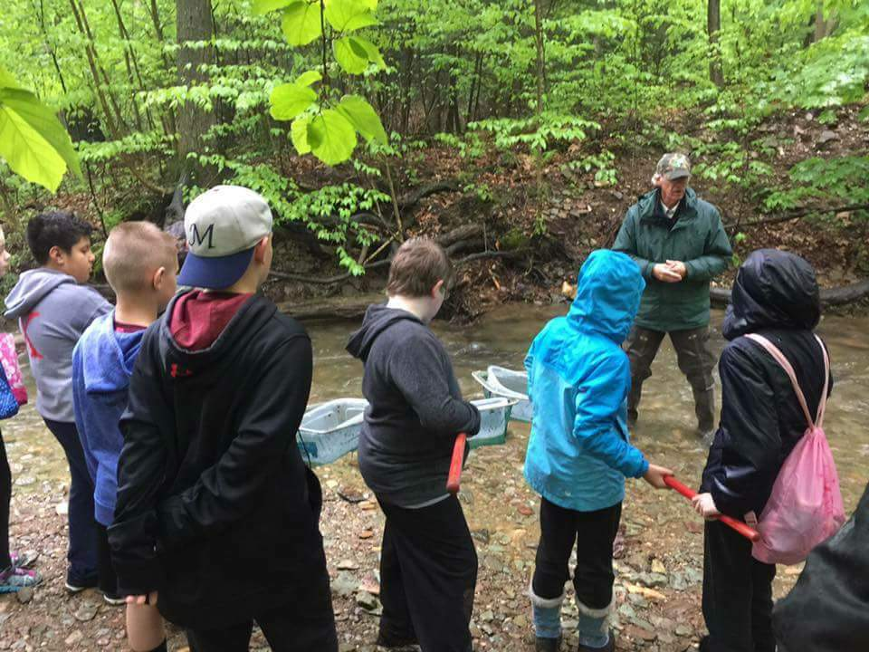
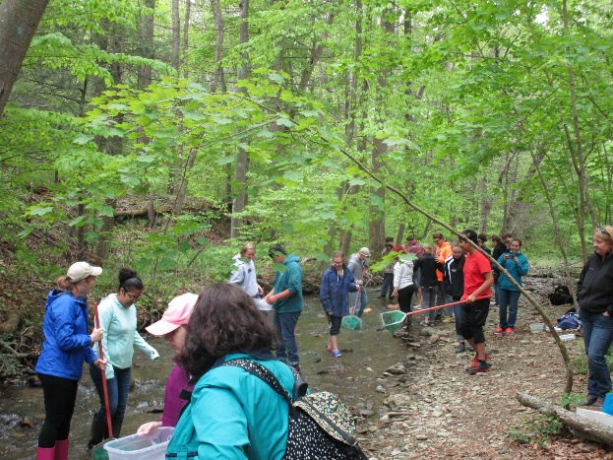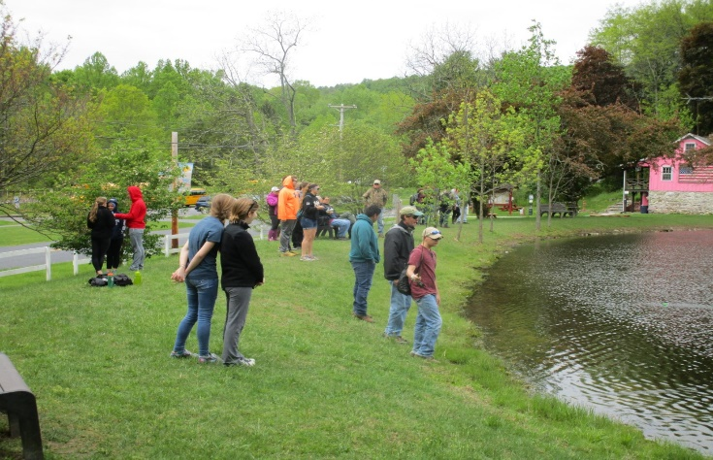
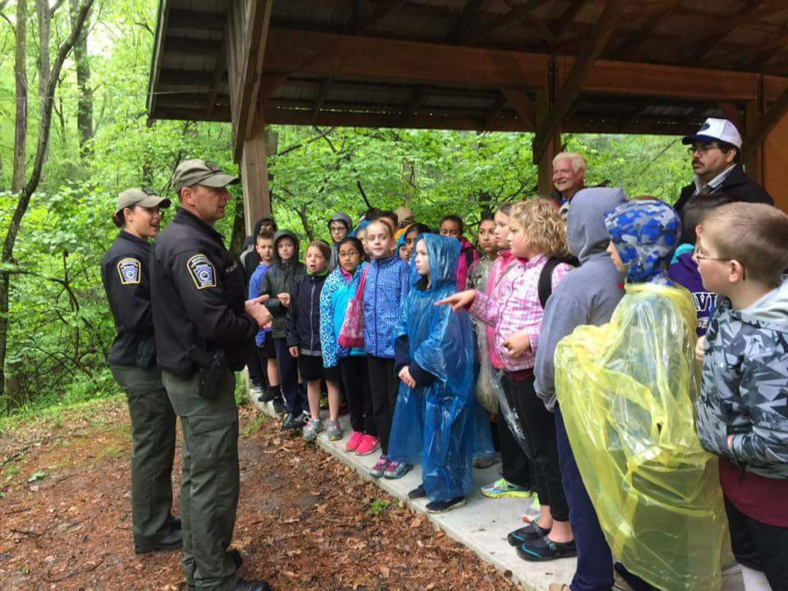
RESTORATION WORK PLANS IN LINE FOR THE CONEWAGO FLY STRETCH
The chapter is gearing up to get our feet wet once again. On July 15 rain date July 22 plans are being approved to keep working on repairs in the fly stretch. Our stream coordinator has received notification and approval of required permits to begin the following repairs: install decking on a mudsill, build a low flow channel block, and work on a log defector. Please bring waders or hip boots, tools will be provided by the chapter. Remember you can make a difference, our mission statement is to protect, conserve and restore our fishery.

LATIMORE FISHING DERBY- FAMILY OUTING. On May 6, excited children and their families once again converged on the children’s section of Latimore Creek to try their luck at catching a trout.
Yellow Breeches Anglers and Conservation Association Cooperative Nursery arrived with a truck full of fish, and the youngsters enjoyed carrying them to the creek for release. At the sound of the air horn, eager anglers tossed their baited hooks into the stream, and tried to land the biggest fish. After 3 hours of fishing, and measuring of many fish by volunteers, a choice of rods was the reward for those in each of the four age groups who caught the longest fish. Every child who registered got to choose from a variety of door prizes to take home with them. Hot dogs were cooked, drinks and chips were served to the children and their families by TU members. Everyone had a great time and enjoyed Dean’s favorite hotdogs on a dreary day. Miscellaneous Donations:
YBAC – Trout (they put some really NICE trout in this year)
Martin’s Potato Chips – 60 individual bags of chips
Hickory Falls – Free Passes (split and gave with fishing rods to the winners)
Cabelas Fishing Rods (gave as prizes) and coupons (gave to parents)
Dicks - $50 Gift Certificate (used for fly rod combo); coupons (gave out to parents)
B&B Lures – Fishing Rod combo (prize)
Loch Haven Lures – Lures left from last year, put on prize table
York Revolution – Family 4 pack including hat and other Revolution Items (door prize)
Harrisburg Senators – Family 4 pack (door prize)
Harrisburg Riverboat – Family 4 pack (door prize)
Philadelphia Phillies – Family 4 pack to Phillies vs. Rockies game (door prize)
Cadbury-Schweppes - Juice Boxes

SOUTHCENTRAL Outdoors for Youths was held this past Saturday at the York & Adams Club with chairman Joe Whitmore heading up the fly tying event. With 146 kids attending this event Joe along with his help had their hands full. There were 10-12 kids in a group with 12 stations to attract their attentions. Hopefully some pictures will follow next newsletter along with some of the great catches at the Latimore fishing derby.

Our chapter newsletter is in need of help. If you have any experience or no our basic design we need your help.

